PebblePad Guidance for in School Mentors

Introduction
PebblePad is the e-portfolio used by PGCE trainees at the University of York. It is a well-established, online portfolio software package used by many UK universities. It is particularly suited for professional related programmes. We trailed PebblePad with our Science and Modern foreign Languages trainees last year and the feedback was resoundingly positive from trainees, University tutors and school mentors. We have implemented changes to this year’s portfolio based on feedback from users that will hopefully make the experience even better.
The PebblePad portfolio provides the trainee with a space to record their experiences, activities, achievements and reflections during placement 1 and 2 and contains all the mandatory documents that are required to be completed during each placement.
As an external assessor you will be required to sign off a trainee’s attendance, mentor meetings and complete the trainee’s reviews for that placement on PebblePad. Alongside University tutors you can also use PebblePad to check on a trainees overall progress, their personal details and evidence as we go though the course.

Access
When a PebblePad account is created you will be sent login details to your work email account. You must keep these details safe as you will need them to access your student’s electronic ongoing achievement record. You must never share your login details with anyone else. If you have not received login details please use the help contacts at the end of this document.
To find PebblePad you can:
- Search Google for ‘PebblePad York’ or
- Enter http://v3.pebblepad.co.uk/login/york in the search bar
Once you have found the site you can save it in your ‘favourites’ for easy access the next time you want to login

How to use PebblePad
When you log on to your PebblePad account using your work email and password, a page with the PGCE QTS portfolios that have been linked to you from your trainees, should appear. The name of the trainee will be shown next to the blue assessment box on the shared portfolio. If you click on the 2022-2023 PGCE Portfolio for a trainee it will open their portfolio.
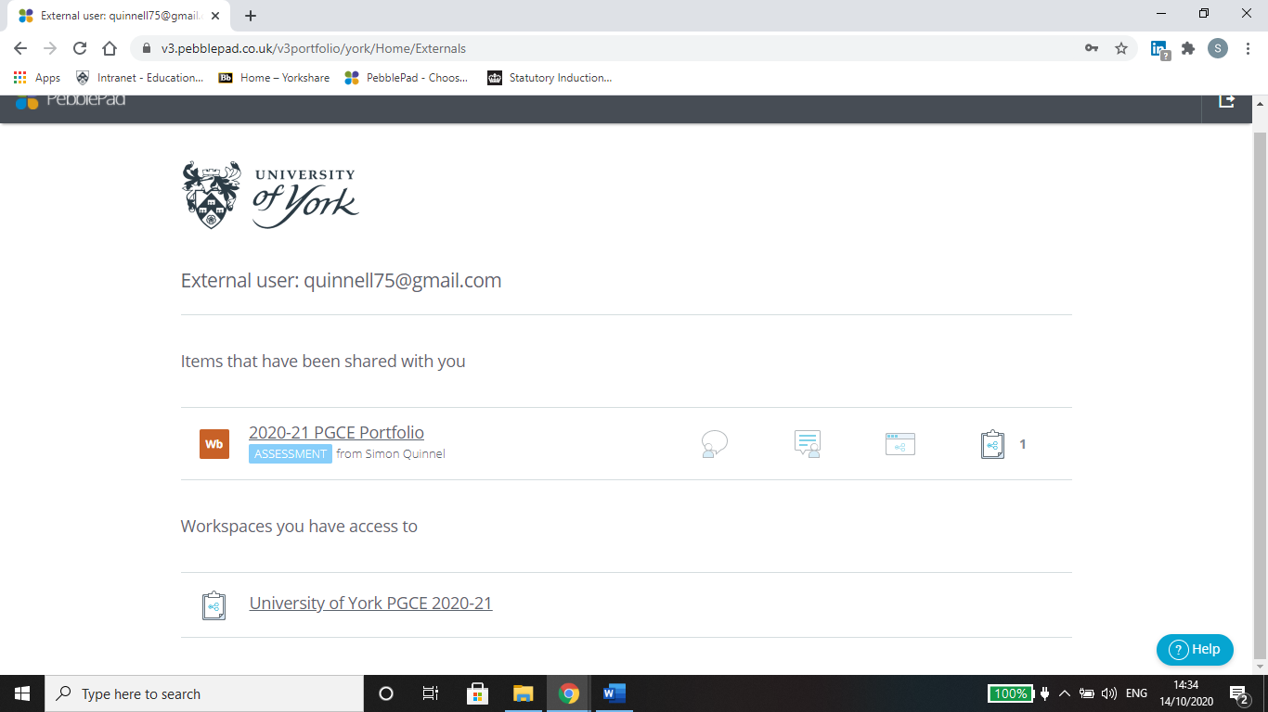
The trainee will also have shared their portfolio by email and you can follow that link to the portfolio as well. Please ignore the University of York PGCE 2022-2023 link.
On the portfolio you can only edit the ‘assessor fields’ which are marked by a blue box, once you have edited you must then go the bottom of the page to save the edit you have made. Once you have saved, the trainee will receive a notification that this has happened.
Each PebblePad is structured in the same way with a series of tabs at the top that open pages for trainees to collect their evidence on and for you to add comments, confirm evidence and to complete reviews. Where tabs have a downwards arrow they will open a drop down menu which shows more pages. To move across the tabs there is a side arrow to the top right of the screen which will allow you to see the rest of the tabs.
To return to the page with the links to all your trainees portfolios click on the PebblePad logo at the top left of the screen.

Tabs and Pages you will need to use

The good news is that are there are very limited parts of your trainee’s PebblePad portfolio that you will need to access and essentially the tabs you will need to access are just electronic versions of the same documents you used to sign by hand or do in a Word document previously. We have deliberately kept these documents similar to last year so that they feel familiar to you as a mentor.

Placement 1 and 2: Attendance Log
The attendance log will be filled in by the trainees to record their attendance at school from their induction time in placement 1 through to the end of placement 2. As a mentor you will need to say whether this is an accurate record or not by checking the tick box at the end of each placement block. At the end of the attendance log page there is a comments box for you to use if there are any concerns or discrepancies. Please add any concerns you have regarding attendance in this box.

Placement 1 and 2: School Information
On the school information tab, can you make sure that the details for school subject mentor and professional tutor are correct (this needs to be changed by the trainee).

Placement 1 and 2: Weekly Mentor Meeting
The weekly mentor meetings (where forms are used to set weekly targets) are to be uploaded by the trainee throughout placement 1 and 2. So actually you will continue to use the one page weekly form with your trainee in the mentor meetings – it is their responsibility to upload these once completely filled in and signed off and dated by you as mentor.
At the end of the PebblePad page for weekly mentor meetings, you will need to confirm if the trainee has attended all the mentor meetings you have had together and uploaded suitable records for each of these meetings. If they have not, please use the comment box to give further details on why they have not attended or uploaded suitable records. The page for this can be found under the Placement 1 and 2 tabs according to which placement your trainee is with you.

Placement 1 and 2 Review forms
The trainee’s usual review forms for each placement (X2) need completing within PebblePad and every box that has the blue assessor’s field will need completing by the mentor. The reviews need to be completed by the deadline date. The trainee fills in their section on PebblePad as well, and now, you can read this as their mentor. At both the end of the Subject Mentor part and the trainee part you will need to confirm completion.
The reviews are:
- Placement 1 Review 1 (completed in PebblePad by mentor by and trainee by 9/12/22
- Placement 1 Review 2 (completed in PebblePad by both mentor and trainee by 3/2/23
- Placement 2 Review 1 (competed in PebblePad by both mentor and trainee by 24/3/23
- Placement 2 Review 2 (completed in PebblePad by both mentor and trainee by 12/5/23
The page for this can be found under the Placement 1 and 2 tabs according to which placement your trainee is with you.

Professional Learning: Learning and Reflection Tool
This area if for trainees to reflect on their University based sessions, in school observations, and their teaching practice over their placement blocks. This is optional but may be required as support for trainees to record evidence if needed. As a Subject mentor you do not need to do anything here, but it does give you some insight into what your trainees have done elsewhere.

PGCE Support Plan
A bespoke support plan may be drawn up to help any trainee whilst on placement to move them from requires improvement to good, or at any point during the ITT year to support those in danger of failing the course. The support plan will be initiated, monitored and reviewed JOINTLY by the University Tutor and the Subject mentor. If you think that a trainee needs to be on a support plan you can start the process on the form but you will need to ensure that the University Tutor, CA Lead Tutors and the trainee are aware of this.

Help
If you need any support on PebblePad please contact:
The PGCE administrator education-pgce-administrator@york.ac.uk or Simon Quinnell simon.quinnell@york.ac.uk
Feedback
If you have any feedback at all on using PebblePad please send a message to:
The PGCE administrator education-pgce-administrator@york.ac.uk or Simon Quinnell simon.quinnell@york.ac.uk

